A watershed-specific formula to predict coho salmon reproduction using functional flow metrics

Claire Kouba, Jason Wiener, Leland Scantlebury and Thomas Harter

DRAFT FIGURES AND TABLES Feb 2025

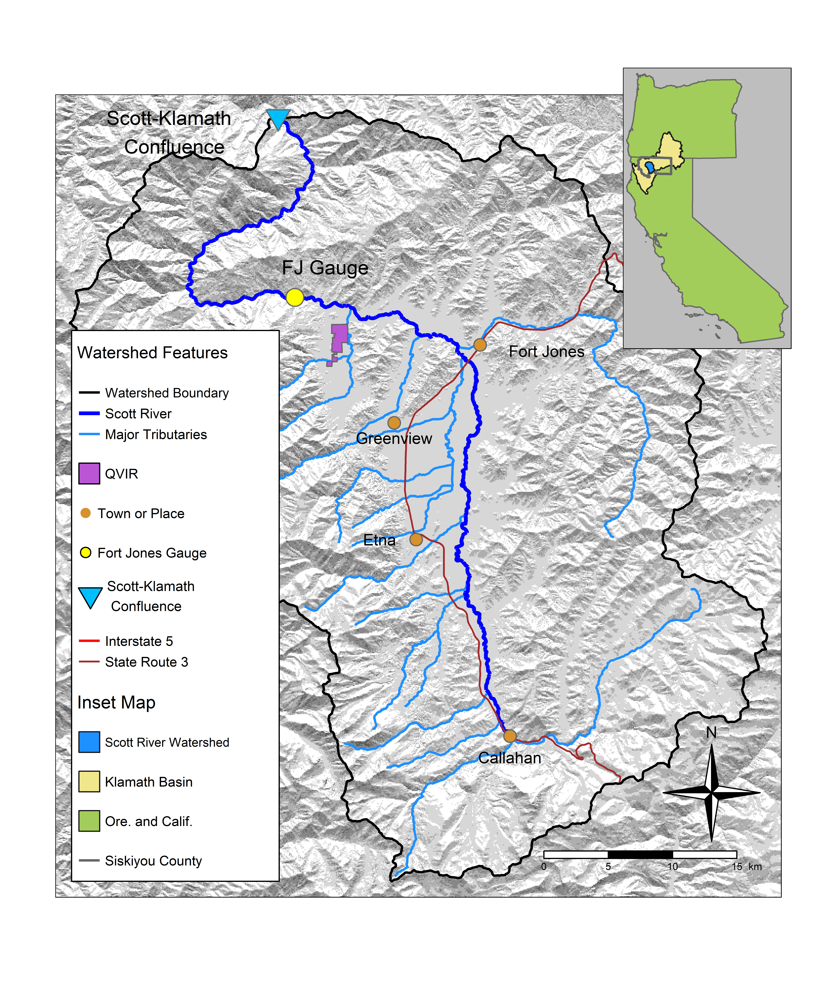

Figure 1: The Scott River watershed, with regional geographic context (see inset) and local features.



Figure 2: Each translucent line traces one annual hydrograph measured at the Fort Jones gauge, and the darker lines illustrate the 30-day smoothed median daily flow in Dry, Below Average, Above Average, and Wet water year types, for water years 1942-2023. The water year type is defined by quartiles of the distribution of total annual flow.



Figure 3: Seasons (as defined in the California Environmental Flows Framework; Yarnell et. al 2020) and life stages experienced by a coho and a Chinook salmon cohort in the Scott River watershed. Season identifiers listed here are used throughout the document.

Table 1: Explanation of season identifiers used in this analysis (displayed graphically in Figure 3).

| Abbrev. | Description | Salmon Life Stage | Species Affected |
| --- | --- | --- | --- |
| d1 | First dry season | Dry season before/during parents' spawning | Coho, Chinook |
| f1 | First fall rewetting | Fall rewetting during/after parents' spawning | Coho, Chinook |
| w1 | First wet season | Eggs, juvenile fish | Coho, Chinook |
| s1 | First spring recession | Rearing juveniles/outmigrating smolt | Coho, Outmigrating Chinook |
| d2 | Second dry season | Rearing juveniles | Coho |
| f2 | Second fall rewetting | Rearing juveniles | Coho |
| w2 | Second wet season | Rearing juveniles | Coho |
| s2 | Second spring recession | Outmigrating smolt | Outmigrating Coho |

Table 2: TO UPDATE. Explanation of hydrologic metrics used in this analysis. Each type of metric, for each threshold value (e.g., 100 cfs or 50th flow percentile), produces one value per water year. Example metric names also include abbreviations for salmon life periods described in Table 2 below.

| Abbrev. | Full Name | Thresholds | Description |
| --- | --- | --- | --- |
| DS_Dur_WS | Dry Season Duration | -- | Dry-season baseflow duration (# of days from start of dry season to start of wet season) |
| DS_Tim | Dry Season Onset Timing | -- | Dry-season baseflow start timing (water year day of dry season) |
| DS_Mag | Dry Season Flow Magnitude | 50th and 90th flow percentile | Percentile of daily flow within dry season. |
| FA_Dur | Fall Pulse Duration | -- | Duration (# of days) of the fall pulse event |
| FA_Mag | Fall Pulse Magnitude | -- | Peak magnitude of fall pulse event (maximum daily peak flow during event) (cfs) in relevant lifestage. |
| FA_Tim | Fall Pulse Timing | -- | Start date of fall pulse event in water year days |
| FA_Dif_num |  |  |  |
| Wet_BFL_Dur | Wet Season Baseflow Duration | -- | Wet-season baseflow duration (# of days from start of wet-season to start of spring season) |
| Wet_BFL_Mag | Wet Season Baseflow Magnitude | 50th and 10th percentile | The magnitude of the median rate of baseflow (i.e., non-storm flow) during the wet season. |
| Wet_Tim | Wet Season Onset Timing | -- | Start date of wet-season in water year days |
| Peak_Dur | Duration of high-flow events | 2, 5, and 10-year return interval | Number of days exceeding the 2, 5 and 10 year recurrence intervals of annual peak flow (50%, 20%, and 10% exceedance values). |
| Peak_Fre | Frequency of high-flow events | 2, 5, and 10-year return interval | Number of times that flow crosses over the threshold values for the 2-, 5- and 10-year flow (50%, 20%, and 10% exceedance values). |
| Peak_Tim | Timing of first high-flow event in a water year | 2, 5, and 10-year return interval | Timing of first exceedance of threshold value for the 2-, 5- and 10-year flow (50%, 20% and 10% exceedance values), in water year days |
| Peak | Magnitude of high-flow events | 2, 5, and 10-year return interval | Single value for each threshold corresponding to the 2-, 5- and 10- year flow exceedance values, in cfs |
| SP_ROC | Spring Recession Rate of Change | -- | Spring flow recession rate (median daily rate of change over decreasing periods during the recession) |
| SP_ROC_Max |  |  |  |
| SP_Dur |  |  |  |
| SP_Mag |  |  |  |
| SP_Tim | Spring Onset Timing | -- | Start date of spring flow recession in water year days |
| Mean_Ann_Flow |  |  |  |
| WY_Cat |  |  |  |



Figure 4: Figure 2 from Yarnell et al., 2020. Illustration of five functional flow categories identified for a mixed rain-snowmelt runoff river in California.

Table 3: Explanation of custom hydrologic metrics designed for this study, which are less complex than functional flows in that they do not rely on signal processing techniques. Each type of metric, for each threshold value (e.g., 120 cfs), produces one value per water year. Metric names used in predictive modeling also include abbreviations for salmon life periods (Table 3 below); e.g., f1_recon_120, referring to the timing of flow exceeding 120 cfs in a ohort's first fall season.

| Abbrev. | Full Name | Thresholds | Description |
| --- | --- | --- | --- |
| recon | River Reconnection Day (for a given life stage and threshold) | 20, 120 | The day, usually in the fall, on which the Scott River gains a certain degree of connectivity. Defined as the first day on which FJ Gauge flow rises above a designated threshold (e.g., 20 cfs) (units of days after Aug. 31). Assigned to a salmon lifestage using a season identifier such as f1 (first fall, experienced by a cohort's spawning parents). Example: f1_recon_20 |
| discon | River Disconnection Day (for a given life stage and threshold) | 20, 120 | The day, usually in the spring or early summer, on which the Scott River loses a certain degree of connectivity. Defined as the first day on which FJ Gauge flow drops below a designated threshold (e.g., 120 cfs) (units of days after Aug. 31). Assigned to a salmon lifestage using a season identifier such as s2 (second spring, experienced as outmigrating smolt). Example: s2_discon_120 |
| num_days_gt_90_pctile | Number of days of high-flow events | 90th flow percentile | Number of days in a water year in which the FJ daily average flow exceeded the 90th percentile flowrate in the full FJ Gauge record. |

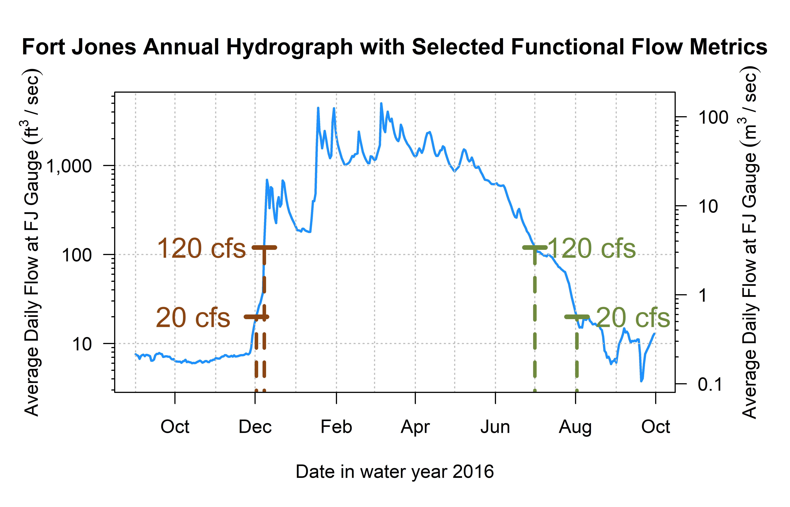

Figure 5: Reconnection and disconnection dates are highlighted for one water year. Two example thresholds, 10 and 100 cfs (0.28 and 2.8 cms, respectively) are highlighted, which correspond to distinct river connectivity (and salmon habitat access) conditions in the Scott River watershed as observed at the Fort Jones gauge (see Results for more detail on selection of flow thresholds).



Figure 6: Total annual flow volume (panel A) and functional flow metrics (panels B-H; Patterson et al. 2020), derived from daily average flow measurements at the Fort Jones USGS flow gauge (ID 11519500) for water years 1942-2023.



Figure 7: Disconnection and reconnection dates for the 120 cfs (3.4 cms) flow threshold, water years 1942-2023. The disconnection date refers to the first day in the spring on which flow drops below the designated threshold (120 cfs); the reconnection date refers to the first date in the fall on which flow rises above the designated threshold. Trends over the past 80 years suggest that the spring flow recession is trending earlier, and the fall river reconnection is trending later.

Table 4: Groups of collinear predictors (absolute value of R greater than 0.7), interpretation of their hydrologic significance, and the predictor selected from each group to reduce collinearity.

| Group of Collinear Predictors | Hydrologic Significance | Predictor Selected from Group |
| --- | --- | --- |
| wy1_Mean_Ann_Flow, s1_discon_20, s1_discon_120, f2_recon_20, w1_Wet_BFL_Mag_10, w1_Wet_BFL_Mag_50, s1_SP_Dur, s1_SP_Mag, wy1_WY_Cat, d2_DS_Tim, d2_DS_Mag_50, d2_DS_Mag_90, w1_num_days_gt_90_pctile | How wet the wet season (year 1, as eggs and fry) | w1_Wet_BFL_Mag_50 |
| wy2_Mean_Ann_Flow, s2_discon_120, w2_Wet_BFL_Mag_10, w2_Wet_BFL_Mag_50, s2_SP_Dur, s2_SP_Mag, wy2_WY_Cat, w2_num_days_gt_90_pctile | How wet the wet season (year 2, as rearing juv.) | w2_Wet_BFL_Mag_50 |
| d1_DS_Tim, f1_recon_20, d1_DS_Dur_WS, d1_DS_Mag_50 | How dry the dry season (pre-spawning) | d1_DS_Mag_50 |
| w2_Wet_Tim, d2_DS_Dur_WS, f2_FA_Tim, w2_Wet_BFL_Dur | Dry to wet transition timing (year 2, rearing juv.) | w2_Wet_Tim |
| w1_Wet_BFL_Dur, w1_Wet_Tim, s1_SP_Tim | How long the wet season (year 1, as eggs and fry) | w1_Wet_BFL_Dur |
| f1_FA_Mag, f1_FA_Dif_num | Fall pulse magnitude (year 1, during parents' spawning) | f1_FA_Mag |
| f2_FA_Mag, f2_FA_Dif_num | Fall pulse magnitude (year 2, as rearing juv.) | f2_FA_Mag |

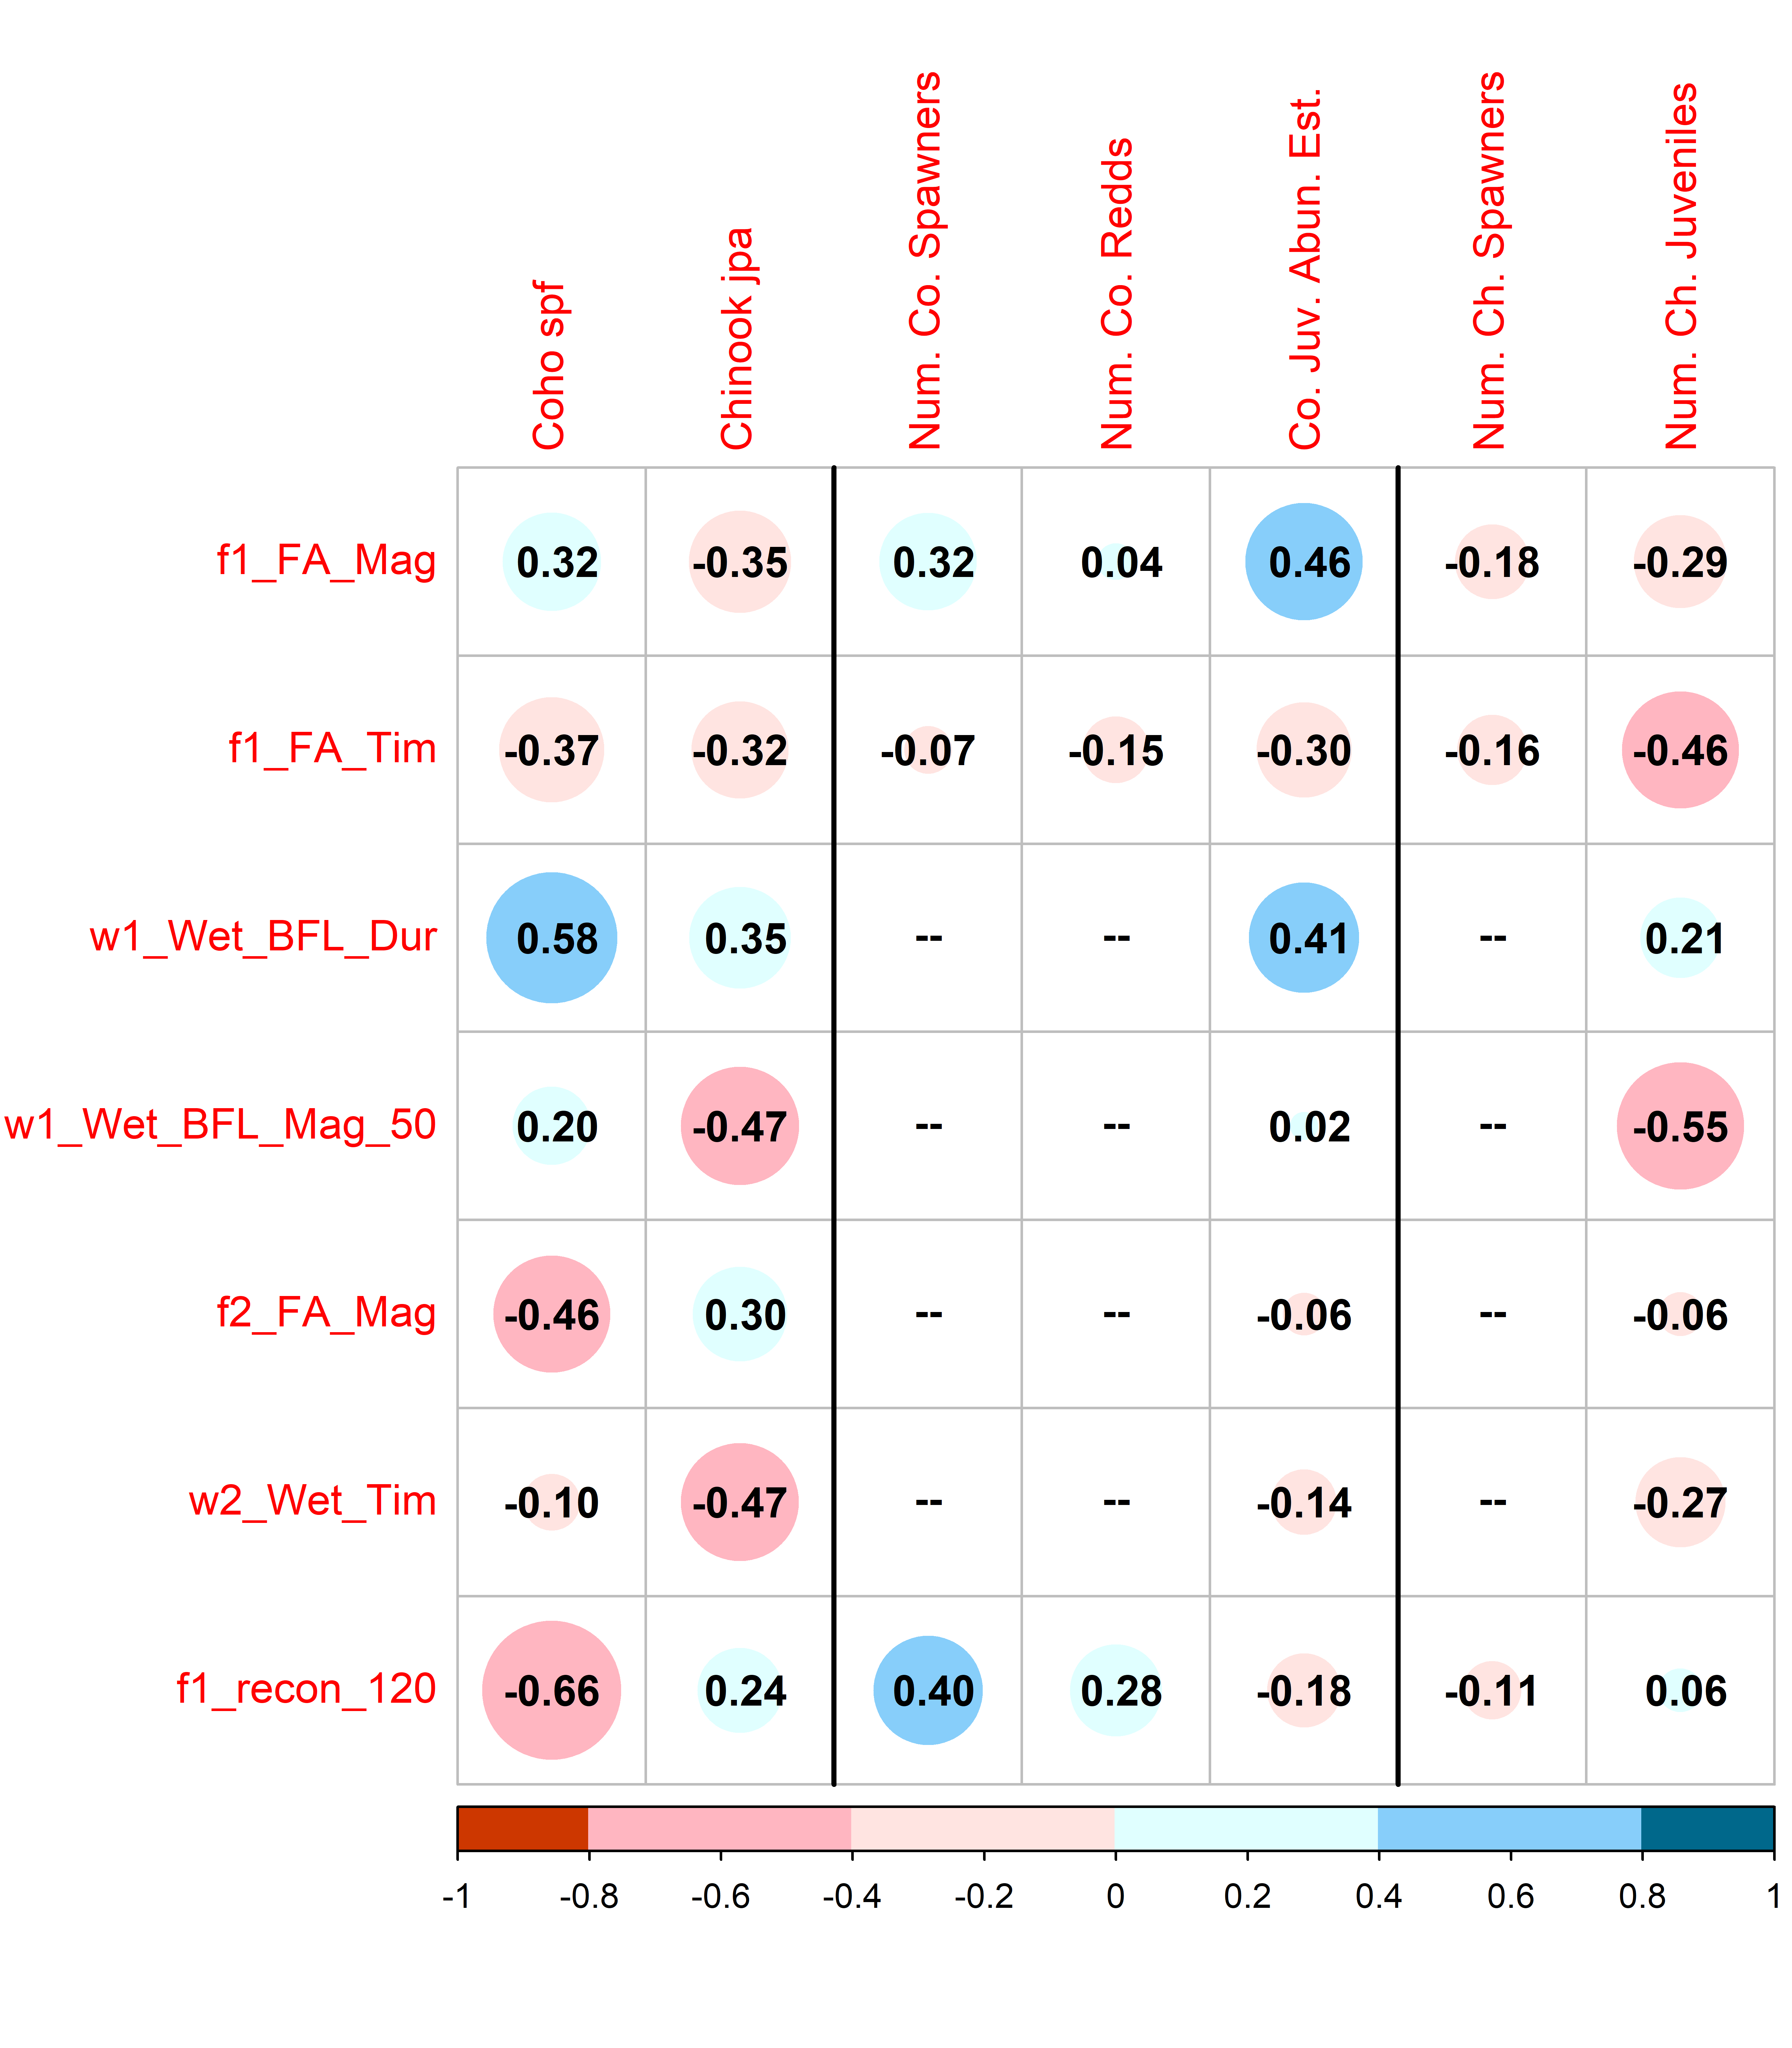

Figure 8: Correlations between 18 predictors and 7 ecological monitoring metrics: the two normalized metrics (left two columns), three additional metrics for coho (center), and two additional metrics for Chinook (right). Red colors indicate a negative correlation and blue colors indicate a positive correlation; the size and color of the circle in each box are both scaled to the value of the correlation coefficient. Large blue circles indicate that the quantity (such as the Brood Year fall pulse magnitude, or BY FA_Mag) is positively correlated with observed fish metrics. For dates, a blue dot indicates that a later date is correlated with higher fish values, while a red dot indicates that an earlier date is correlated with higher fish values. Predictors that produced an absolute R value of at least 0.45 with at least one observed value are shown here; the full suite of calculated R values is shown in Supplemental Figure 1.

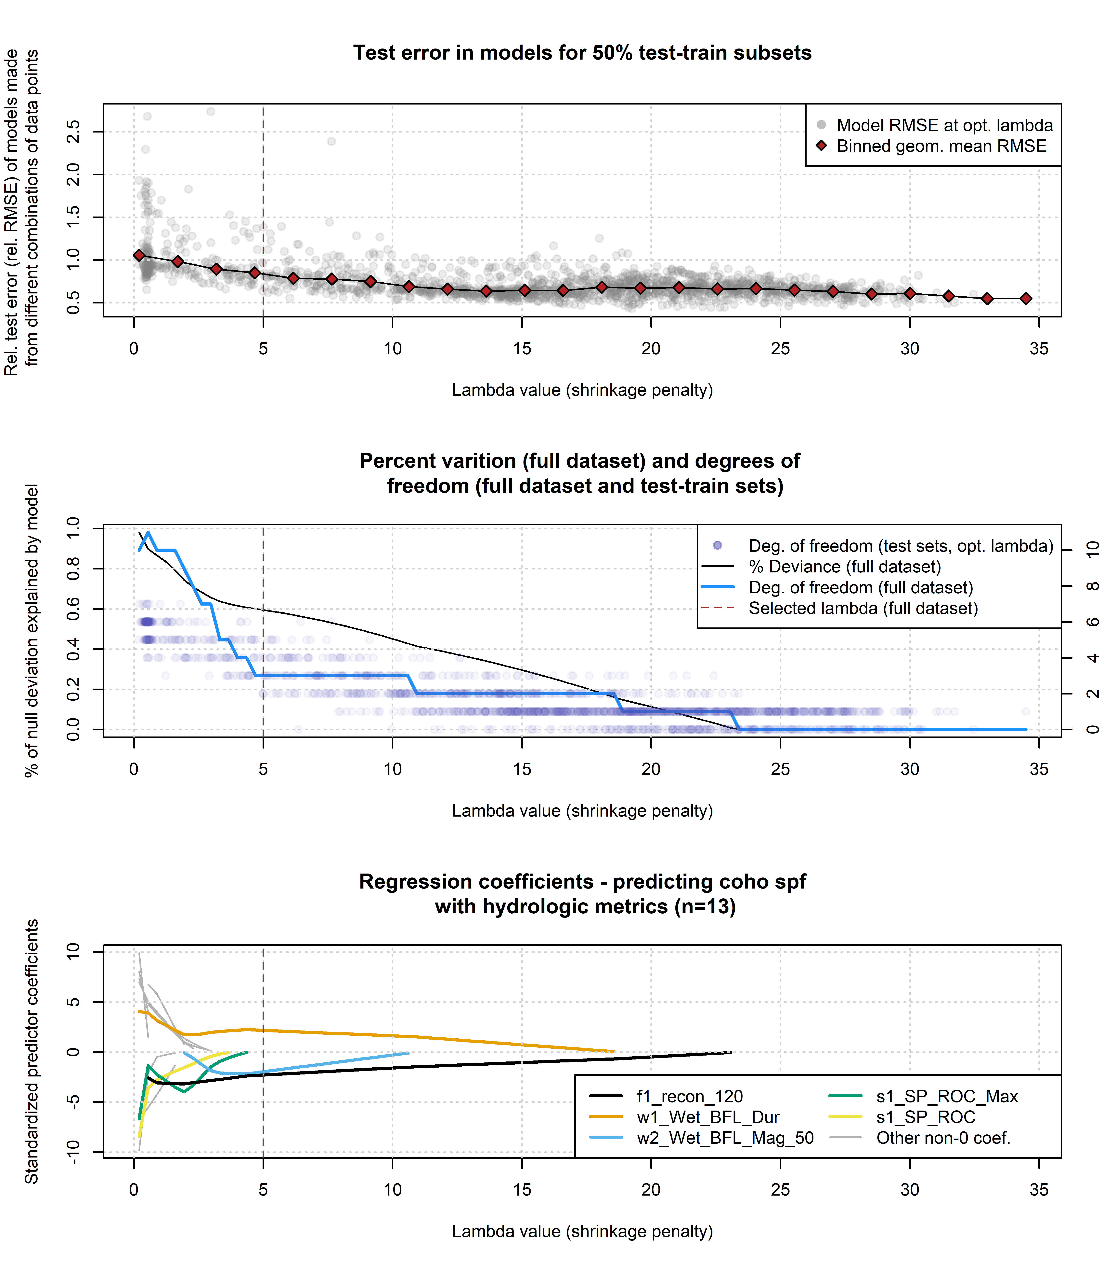

Figure 9: Results of lasso regression to predict coho outcomes with hydrologic metrics. Models with more coefficients explain a greater degree of variation in the dataset (middle panel), but also produce higher test errors (top panel), indicating some overfitting at lower lambda values. Higher values of lambda tend to shrink the absolute values of regression coefficients toward 0 (bottom panel).

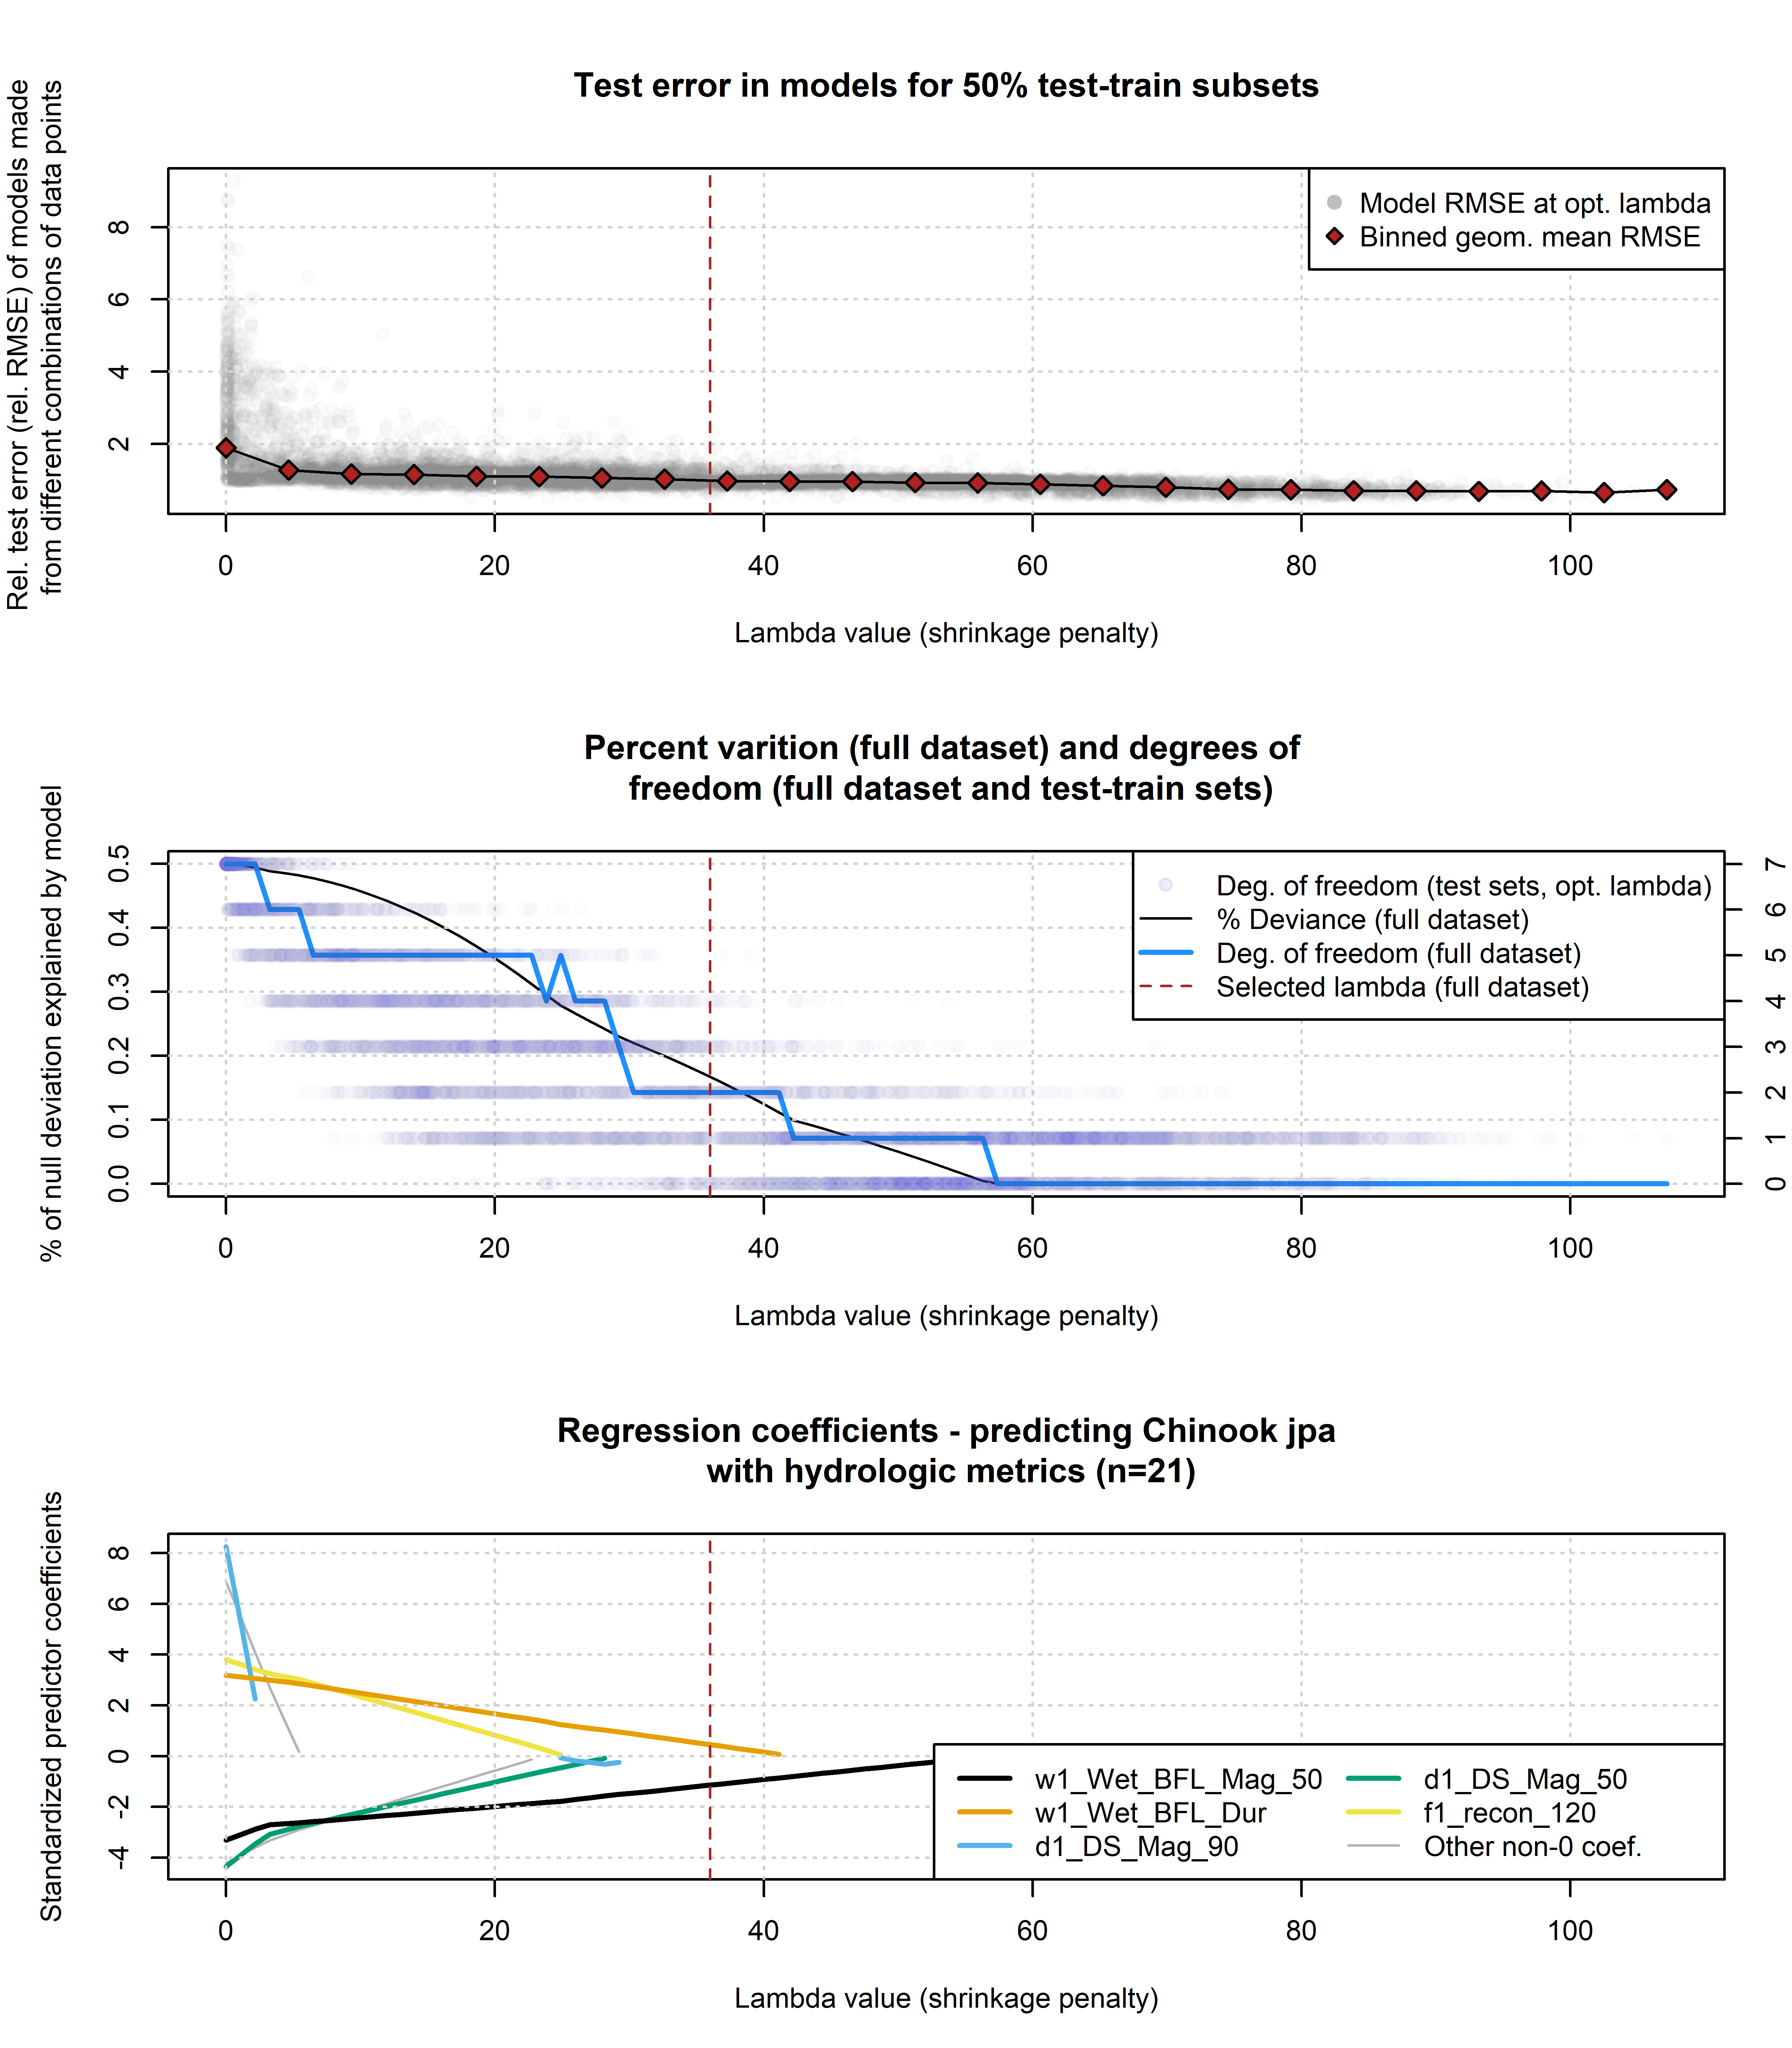

Figure 10: Results of lasso regression to predict Chinook outcomes with hydrologic metrics. Models with more coefficients explain a greater degree of variation in the dataset (middle panel), but also produce higher test errors (top panel), indicating some overfitting at lower lambda values. Higher values of lambda tend to shrink the absolute values of regression coefficients toward 0 (lower panel).

Table 5: Predictors informing the lasso regression for the full dataset of coho spf observations, at decreasing lambda values (also referred to as a shrinkage penalty). Lambda values represent the point at which a non-0 coefficient appears for the designated predictor.

| Order of appearance | Predictor | Non-zero lambda value |
| --- | --- | --- |
| 1 | f1_recon_120 | 23.06 |
| 2 | w1_Wet_BFL_Dur | 18.56 |
| 3 | w2_Wet_BFL_Mag_50 | 10.59 |
| 4 | s1_SP_ROC_Max | 4.36 |
| 5 | s1_SP_ROC | 3.66 |
| 6 | f2_recon_120 | 2.97 |
| 7 | s2_SP_ROC | 2.97 |
| 8 | d1_DS_Mag_50 | 2.28 |
| 9 | s2_SP_ROC_Max | 1.93 |
| 10 | w1_Wet_BFL_Mag_50 | 1.59 |
| 11 | w2_Wet_Tim | 1.59 |
| 12 | d1_DS_Mag_90 | 0.55 |

Table 6: Predictors informing the lasso regression for the full dataset of Chinook jpa observations, at decreasing lambda values (also referred to as a shrinkage penalty). Lambda values represent the point at which a non-0 coefficient appears for the designated predictor.

| Order of appearance | Predictor | Non-zero lambda value |
| --- | --- | --- |
| 1 | w1_Wet_BFL_Mag_50 | 56.29 |
| 2 | w1_Wet_BFL_Dur | 41.14 |
| 3 | d1_DS_Mag_90 | 29.23 |
| 4 | d1_DS_Mag_50 | 28.15 |
| 5 | f1_recon_120 | 24.90 |
| 6 | s1_SP_ROC_Max | 22.74 |
| 7 | s1_SP_ROC | 5.42 |

Table 7: Values for the intercept and coefficient terms in the Hydrologic Benefit function for coho spf, including a description of which phenomena are associated with higher ecological outcome values.

| Predictor | Value | Description |
| --- | --- | --- |
|  | 80.700 | Intercept |
| w1_Wet_BFL_Dur | 0.173 | Longer wet season (as eggs and fry) |
| w2_Wet_BFL_Mag_50 | -0.016 | Lower wet season baseflow (as juvenile fish) |
| f1_recon_120 | -0.491 | Earlier full-system reconnection (120 cfs, fall of parents' spawning) |

Table 8: Values for the intercept and coefficient terms in the Hydrologic Benefit function for Chinook jpa, including a description of which phenomena are associated with higher ecological outcome values.

| Predictor | Value | Description |
| --- | --- | --- |
|  | 144.300 | Intercept |
| w1_Wet_BFL_Dur | 0.156 | Longer wet season (as eggs and fry) |
| w1_Wet_BFL_Mag_50 | -0.054 | Lower wet season baseflows (first wet season, as eggs and fry) |

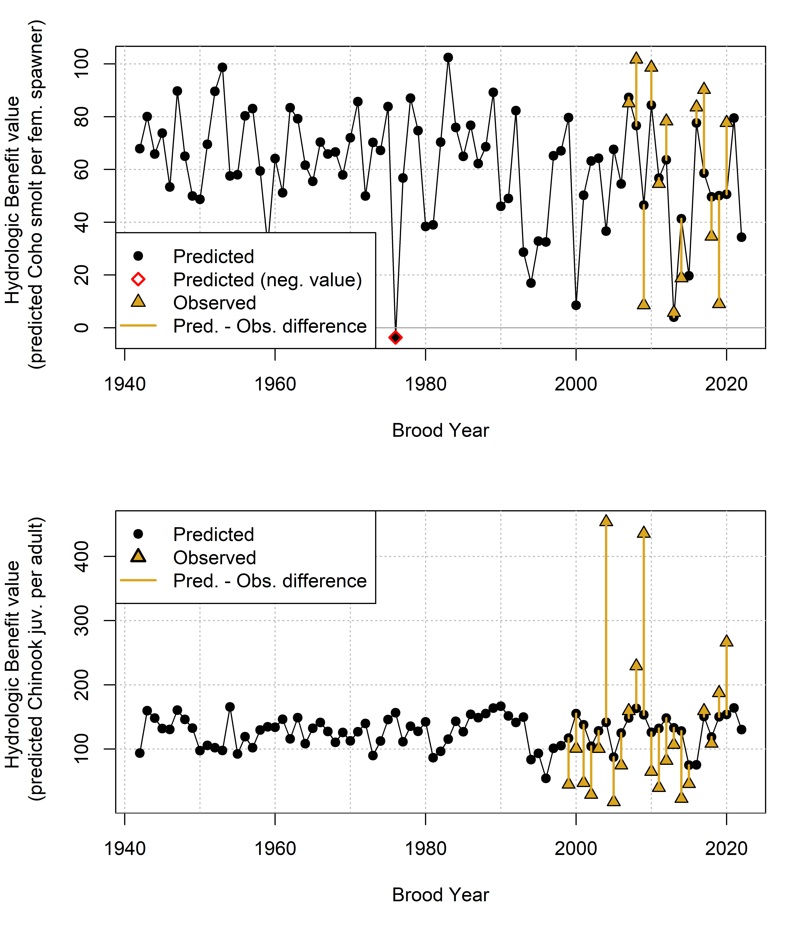

Figure 11: Annual observed and predicted values of coho smolt produced per female spawner (coho spf, top panel) and Chinook juveniles produced per adult spawner (Chinook jpa, lower panel). Predicted quantities (black dots) are shown as Hydrologic Benefit (HB) function values. The predicted and observed values are plotted by each cohort’s Brood Year.

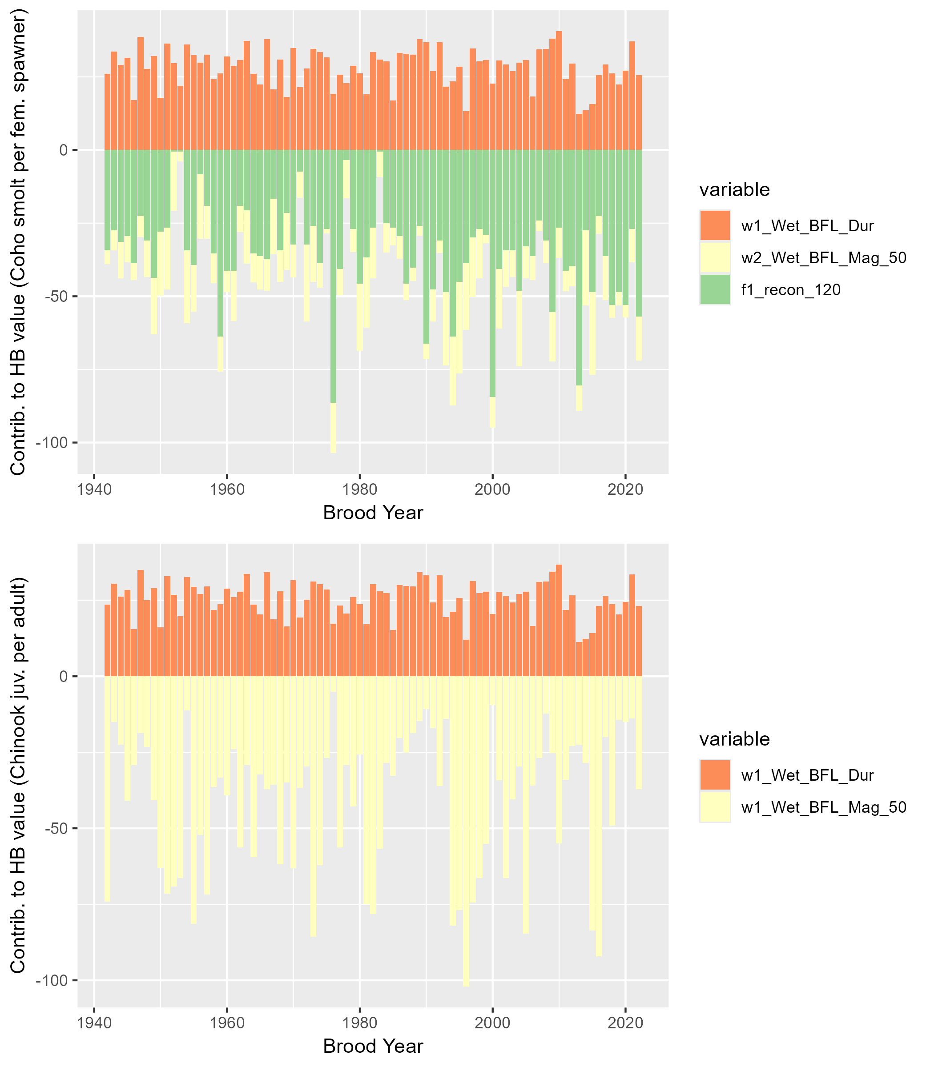

Figure 12: Contributions to annual Hydrologic Benefit values (coho spf-equivalent, top panel, and Chinook jpa-equivalent, lower panel). A positive value indicates that a greater quantity contributes a positive value to the predicted ecological outcome in that cohort (e.g., a later spring disconnection produces more predicted coho spf). A negative value indicates that a larger number contributes a negative value to the predicted outcome (e.g., a later fall reconnection date produces fewer predicted coho spf in that cohort).